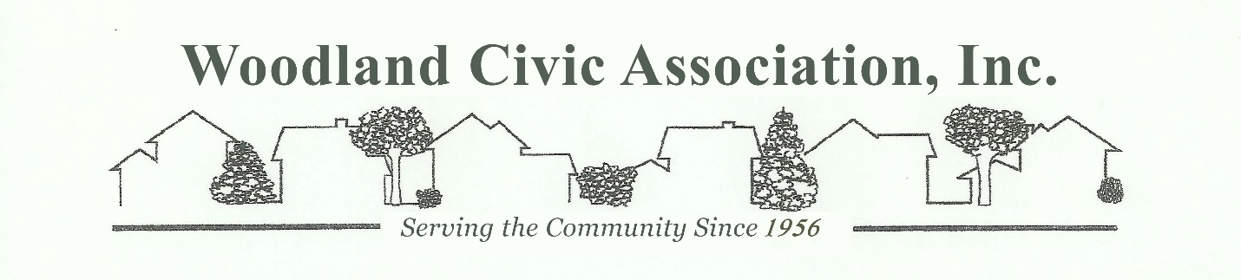

February 11, 2026
Mr. Greg Gaxiola
Environmental Analyst
Town of Babylon
281 Phelps Lane
North Babylon, NY 11703

Dear Mr. Gaxiola,

We have received the Environmental Quality Review Act paperwork for the proposed East Farmingdale Overlay Zone. Woodland Civic Association, Inc. will decline to be the lead agency for this SEQRA review.

We would like to make several comments.
- There is a lengthy list of possibly involved agencies included, but we did not see the Bergen Point Waste Treatment facility or the East Farmingdale Fire Department included in the list. We believe both are important to this group and would like them included in any future correspondence.
- There is a notable lack of information on this full environmental assessment form. There are no project details (D), or site and setting of proposed action (E). This information is the heart of the document but is not included.
- Reference is made in part C4d in regard to parks servicing this project. None of the parks listed are anywhere in proximity to this site and should not be included.
- Maximum building height is listed as 55 feet, with an exclusion for additional structures such as air conditioning units, water tanks, chimneys, etc. of an additional 12 feet. Although construction is technically just outside of the airport runway protection zone, structures of 67 feet in height are excessive and dangerous so close to the third most active airport in New York State per the FAA. Aircraft in distress likely do not follow exact airport approach areas, presenting a danger to residents. Extreme restrictions were invoked for the Acadia construction directly across the street.
- The overlay area does not include Route 110 or the Acadia warehouse site construction on the west side of Route 110. Heavy consideration of the traffic at the Conklin Street and Route 110 intersection must be a primary environmental concern, as this intersection has already been classified as category F, the most congested, without any additional development. Traffic from Acadia warehouse operations must be included in any traffic studies.
- We have been told that a “sweet spot” of no more than 1,400 residential units would be considered. A prior plan to construct 2,700 units on this site was rejected by both the community and the Town of Babylon as being excessive. Since 495 units on the NYSDOT property are within the overlay, and 372 have been proposed already within the Airport Plaza, there should be no more than an additional 533 units within the overlay. Therefore, the size and acreage of this project is unnecessary and should be reduced. Approving the land use as proposed will allow future development that should not be permitted.
- The community does not want to be unwilling financial contributors to this project. As such, there should be no IDA involvement or tax abatements granted, which places tax burdens on existing residents that do not benefit in any way from this proposal. However, we will be dealing with increased traffic and congestion for the foreseeable future.
- The community contribution benefit to be used exclusively in East Farmingdale will only help to mitigate some of the disruption we will experience now and in the future from this project. We would like to see some actual benefit to the existing community, such as a community center or park that we can use.
- The focus of this project is to benefit future people that do not live in East Farmingdale yet, that do not have their life savings invested in homes that they own, with no stake or loyalty to the area. Please recognize at the very least that this overlay should not present any difficulty to your constituents.

We appreciate the opportunity to receive and respond to this information. Thank you.

Nancy Cypser
President
Woodland Civic Association, Inc.
Long Island Civic Alliance, Inc.

Cc:
Rich Schaffer, Town Supervisor, Town of Babylon
Antonio Martinez, Deputy Supervisor, Town of Babylon
DuWayne Gregory, Councilman, Town of Babylon
Anthony Manetta. Councilman, Town of Babylon
Terence McSweeney, Councilman, Town of Babylon
Jennifer Montiglio, Receiver of Taxes, Town of Babylon
Geraldine Compitello, Town Clerk, Town of Babylon
Joseph Wilson, Town Attorney, Town of Babylon
Denise Graziano, Commissioner, Planning and Development, Town of Babylon
Ron Klusener, Interim Commissioner, Dept. of Environmental Control, Town of Babylon
Eric Hofmeister Chief Deputy Commissioner, Dept of Environmental Control, Town of Babylon

